Fictional campaign brief
A generated editable document using invented data. No business performance claim.

Channel totals
Channel | Signups | Spend units
Search | 124 | 976
Social | 132 | 1072
Video | 140 | 1168
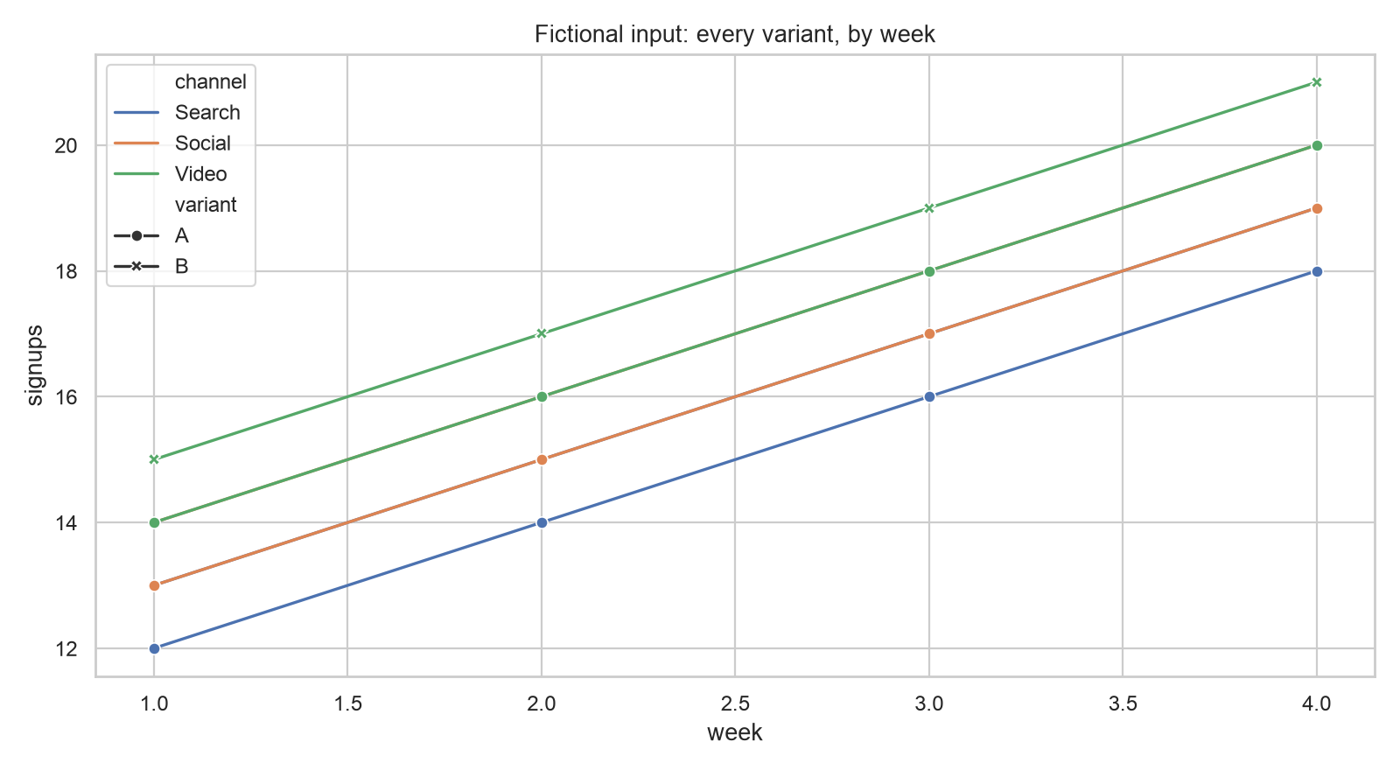
This DOCX was checked structurally. Rendering in Word or LibreOffice was not tested.

